Update of ERP

- When a customer creates a profile, they should receive an email.
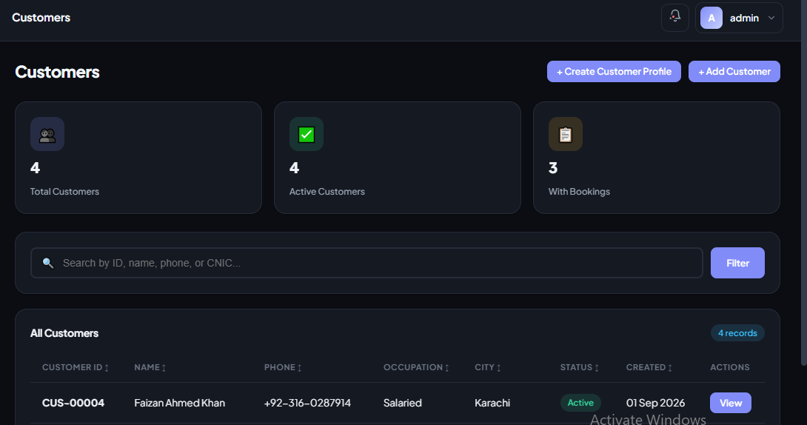

- When we create a project, options to update or delete it should be available.

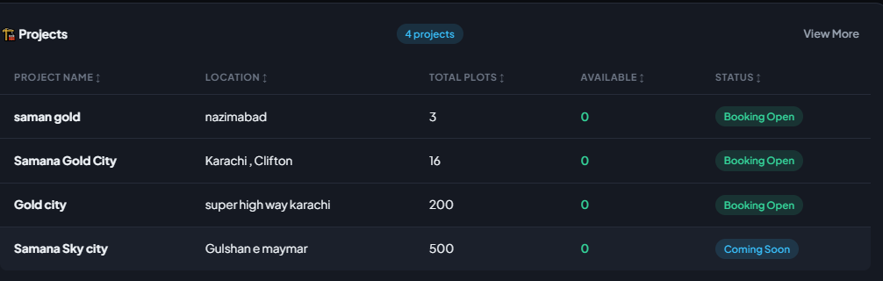

- When we create an office, options to update or delete it should be available.
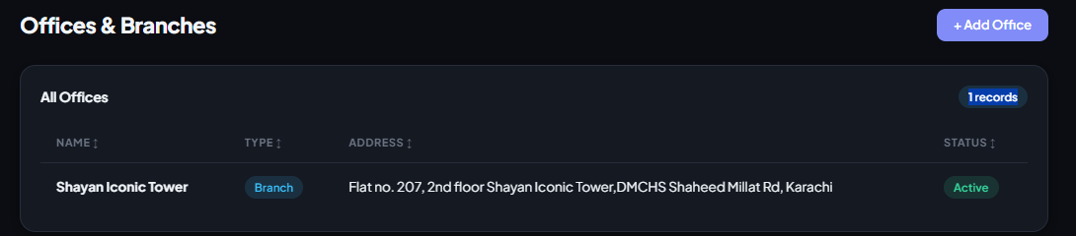

- An error occurs when trying to mark it as paid in payroll.
